EXP 3 CODE:
clc; clear; close all;
% Parameters
fs = 100000; % Sampling Frequency t = 0:1/fs:0.02; % Time Vector
fm = 500; % Message Frequency fc = 5000; % Carrier Frequency
% Message Signal m = cos(2*pi*fm*t);
% Carrier Signal
c = cos(2*pi*fc*t);
% DSB-SC Modulation dsb = m .* c;
% VSB Filter (Low-pass + High-pass Approximation) [b,a] = butter(4, fc/(fs/2));
vsb = filter(b,a,dsb);
% Coherent Demodulation
demod = vsb .* (2*cos(2*pi*fc*t));
% Recover Message
[b1,a1] = butter(4, 1000/(fs/2)); rec = filter(b1,a1,demod);
% Display Results figure; subplot(5,1,1) plot(t,m)
title('Message Signal') grid on
subplot(5,1,2) plot(t,c) title('Carrier Signal') grid on subplot(5,1,3) plot(t,dsb)
title('DSB-SC Signal') grid on
subplot(5,1,4) plot(t,vsb) title('VSB Signal') grid on

subplot(5,1,5) plot(t,rec,'r') title('Recovered Message') grid on

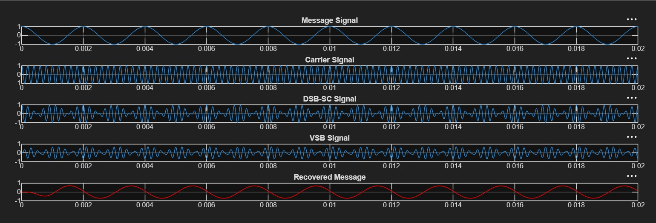
OUTPUT:

